*Town Board* ROBERT TROIANO JR. EDWARD SCOTT

DENNIS WALSH

CHRISTINE LIU

DAVID ADHAMI MARIANN DALIMONTE

## Town Clerk

RAGINI SRIVASTAVA

## Receiver of Taxes

MARY JO COLLINS

**TOWN OF NORTH HEMPSTEAD**

**OFFICE OF THE SUPERVISOR**

**TOWN HALL**

# 220 PLANDOME ROAD

**MANHASSET, NY 11030**

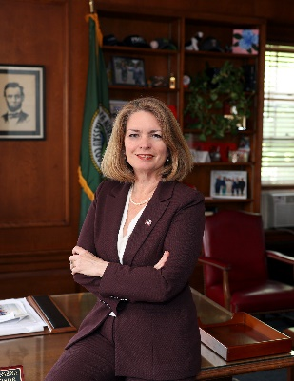

# Jennifer S. DeSena *Town Supervisor*

November 25, 2024

Dear 73rd Annual Journal Dinner Attendees:

I am delighted to extend my warmest congratulations to Great Neck Synagogue as we celebrate your terrific work over the last year while looking forward to an exciting 2025.

As the Supervisor of North Hempstead, I have the privilege of witnessing firsthand the positive impact this congregation and its devoted members have on our town. Today’s event is meant to acknowledge and honor the determined, courageous, and inspiring members who help make Great Neck Synagogue such a great success. On behalf of the Town of North Hempstead, I’d like to personally thank today’s esteemed honorees: **Lisa & Erran Kagan, Leslie & Michael Kule, and Sharon & Mark Twersky** for their remarkable contributions to both the synagogue and the community.

I offer my gratitude to all members of Great Neck Synagogue for your dedication not only to your communal values but also to the Town of North Hempstead. Your work continues to be a shining example of how public service and charity can unite us for a greater purpose.

May you all enjoy a wonderful evening at tonight’s dinner, and once again, thank you for your tireless commitment to enriching the cultural and societal landscape of North Hempstead.

Sincerely,

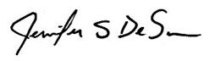

Jennifer S. DeSena,

Supervisor